**Expected Deliverables:**

1. **Survey Questionnaire:**

<https://docs.google.com/forms/d/e/1FAIpQLSepxXy1k-g4GlGRR0diLpj5B4m2pSrbl-8uGjutY8P2q4z6eQ/viewform?usp=header>

1. **Data Collection Plan:**

* Social media platforms such as Whatsapp
* Community boards such as local organizations, forums

1. **Analysis Report:**

* A summary report of the findings once the survey is completed, including key insights and trends.

**Introduction**

This report summarizes the findings from the user survey conducted to understand the challenges faced by individuals seeking rental properties. The survey aimed to gather insights on user demographics, difficulties encountered, desired functionalities, and overall feedback on the proposed housing app.

**Survey Overview**

* **Total Respondents:** 10
* **Survey Duration:** 30/03/2025 – 1/04/2025

**Key Demographics**

**Gender Distribution**

* Male: 50% of the responders where males
* Female: 50% of the responders were females
* Prefer not to say: 0%

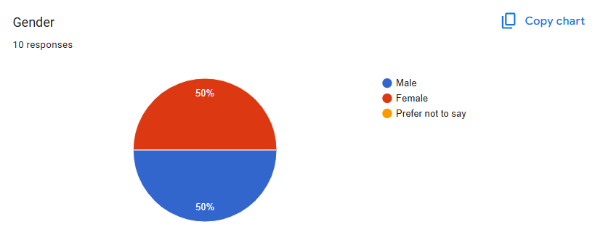

**Age Range**

* Under 18:
* 18-24: 50% of the responders are of this age range
* 25-34: 30% of the responders are of this age range
* 35-44: 0%
* 45-54: 20% of the responders are of this age range
* 55-64: 0%
* 65 and above: 0%

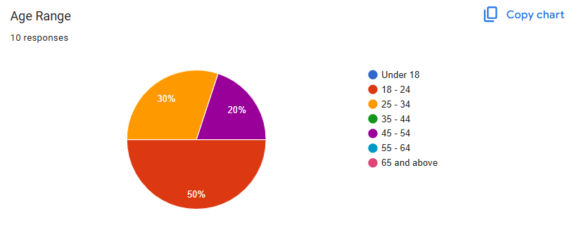

**Income Range**

* Under 41,875 FCFA **40%**
* 41,875 FCFA – 60,000 FCFA **20%**
* 60,000 FCFA – 10,0000 FCFA **10%**
* 100,000 FCFA – 150,000 FCFA **0%**
* 150,000 FCFA – 200,000 FCFA **0%**
* 200,000 FCFA – 250,000 FCFA **0%**
* 250,000 FCFA – 300,000FCFA **0%**
* 300,000 FCFA – 350,000 FCFA **10%**
* 350,000 FCFA – 400,000 FCFA **0%**
* 450,000 FCFA – 500,000 FCFA **10%**
* 500,000 FCFA and above **10%**

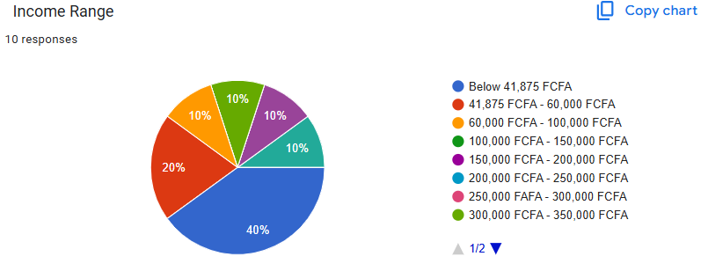

**Geographical Location**

* Urban area: 50%
* Suburban area: 50%
* Rural area: 0%

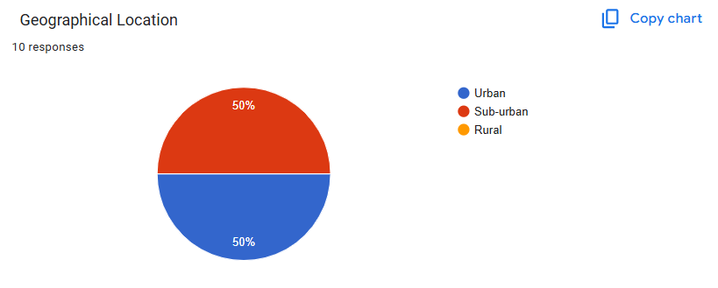

**2. What difficulties have you encountered when searching for rental properties? (Select all that apply**

* High Rental Prices: **80%** of respondents reported this as a significant barrier.
* Limited Availability of Rooms: **80%** indicated difficulty finding suitable rental options.
* High Population Density: **60%** experienced challenges related to overcrowding.
* Difficulties with Credit Checks: **10%** faced issues with credit requirements.
* Lack of Responsiveness from Landlords: **30%** mentioned poor communication as a barrier.
* Other Barriers**: 0%** Respondents specified other difficulties

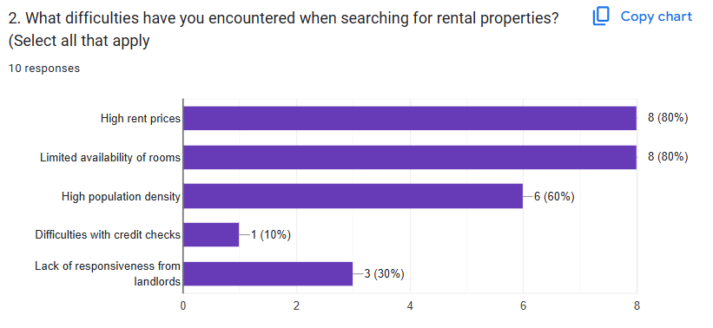

**Feedback on Proposed Solution**

**3. How valuable do you think an app designed to assist with your housing search would be?**

* Extremely Valuable: **90%**
* Somewhat Valuable: **10%**
* Not Valuable: **0%**

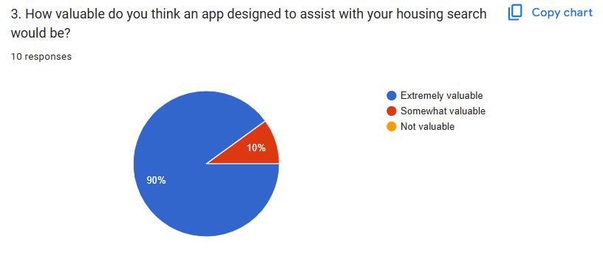

**4. What additional features would you like to see in a housing solution app? (Select all that apply)**

* Advanced Filtering Options: **100%** of respondents expressed interest.
* Neighborhood Insights: **80%** showed a desire for this feature.
* Virtual Property Tours: **80%** indicated this would enhance their experience.
* Real-Time Availability Updates: **80%** showed interest in timely information.
* User Reviews and Ratings for Landlords: **90%** indicated this would influence their decisions.
* Other Features: no respondents suggested other features

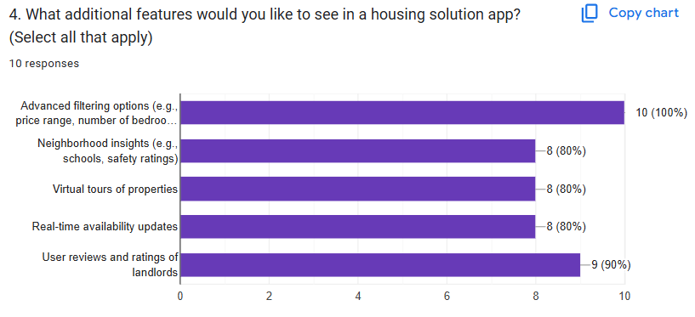

**5. How likely are you to recommend an app like ours to friends or family?**

* **Very Likely:** 90%
* **Somewhat Likely:** 10%
* **Not Likely:**

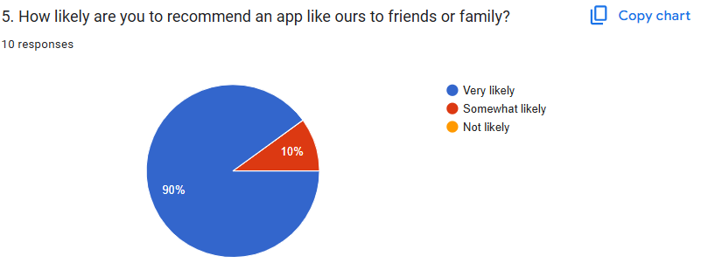

**Key Insights and Trends**

1. **High Demand for Affordability:** Many respondents highlighted the challenge of high rental prices, indicating a need for budget-friendly options in the app.
2. **Desire for Transparency:** Users expressed a strong interest in features that provide neighborhood insights and landlord reviews, suggesting a trend toward transparency in the rental process.
3. **Importance of Responsiveness:** The lack of landlord responsiveness was a common concern, indicating that users value quick and clear communication.
4. **Interest in Technology Integration:** Features such as virtual tours and real-time updates were highly favored, suggesting users are looking for innovative solutions to streamline their housing search.

**Recommendations**

Based on the survey findings, the following recommendations are proposed for the app's design and features:

* **Implement Advanced Filtering Options** to help users find properties that fit their budget and needs.
* **Provide Comprehensive Neighborhood Insights** to help users make informed decisions.
* **Incorporate Virtual Tours** to enhance the viewing experience.
* **Ensure Robust Communication Features** to facilitate better interactions between users and landlords.
* **Develop a Review System** to increase accountability and transparency in the rental market.